(1) Change camera setting to use the VLC player
In [JPEG/H.264] tab from the [Image/Audio] setup page.
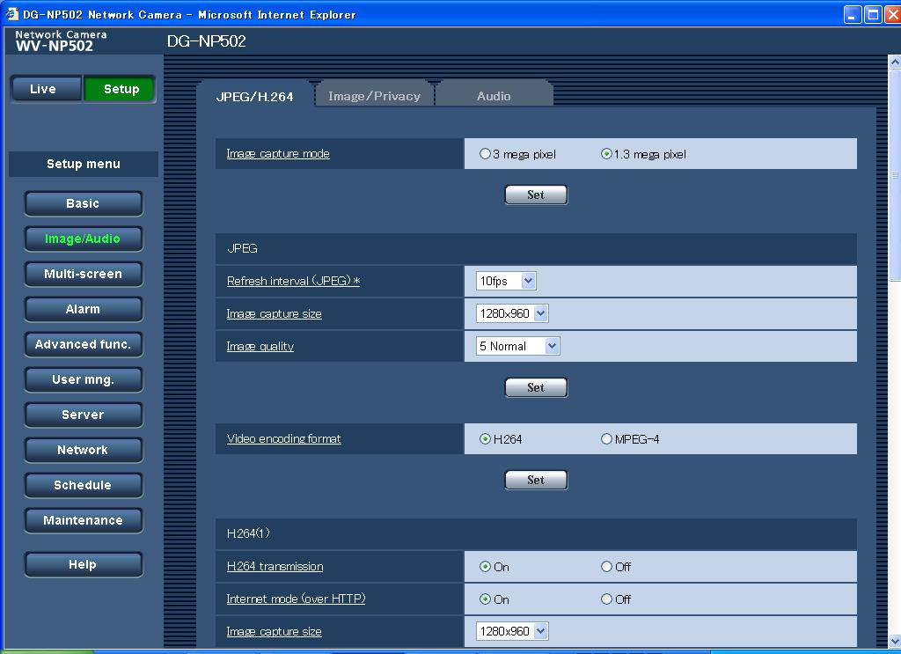
Change the setting to 'ON'
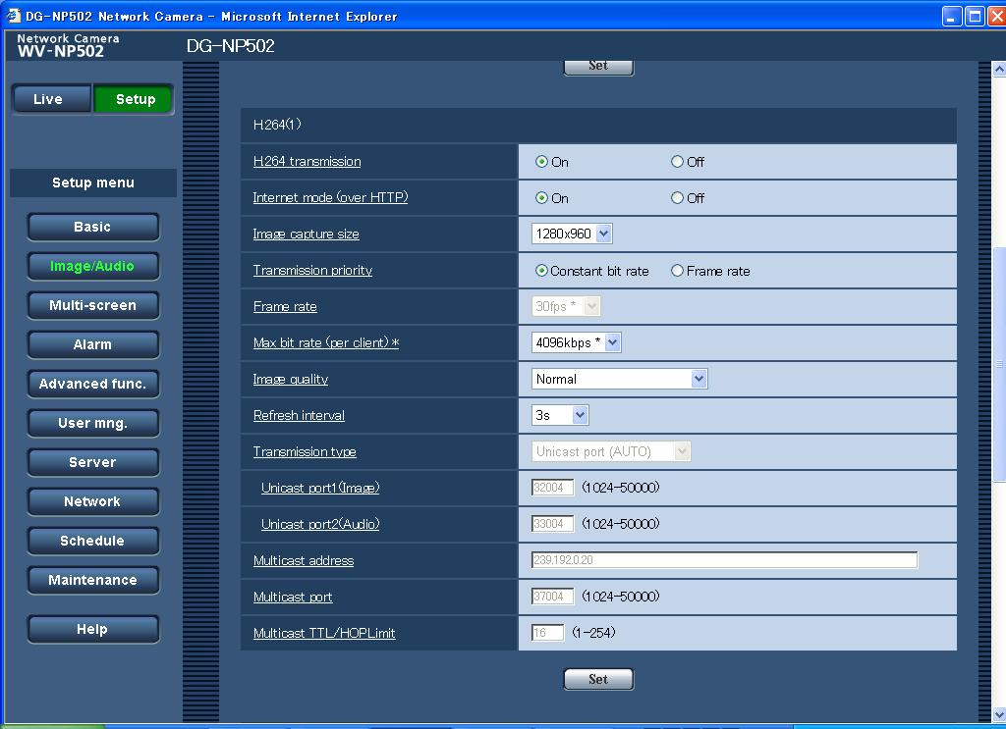
Click 'Set' button

(2) In VLC player, select 'Open Network'.
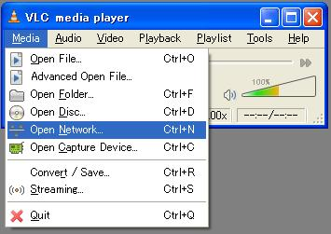
The next dialog is appeared.

(3) Select 'RTSP' and type '192.168.0.10/MediaInput/h264'.
192.168.0.10 is camera's IP address.
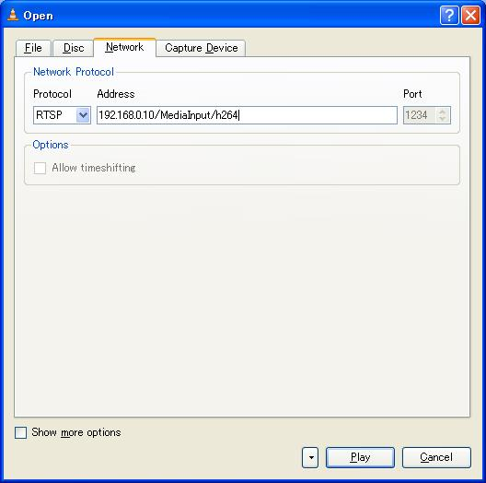
Click 'Play' button

When clicking the Play button, we can see the h264 live view in our environment.
We use the VLC player v0.9.6, and the camera version is 1.01.

